**1.linear level adjustment :**

clear all;

topmax=' ';

disp('Enter the top max level');

top=input(topmax);

bottommin=' ';

disp('Enter the bottom min level');

bottom=input(bottommin);

a1=imread('pout.tif');

a=im2double(a1);

a=uint32(a);

h=0;

l=0;

for row=1:size(a,1)

for column=1:size(a,2)

if a(row,column)>h

h=a(row,column);

end

end

end

for row=1:size(a,1)

for column=1:size(a,2)

if a(row,column)<l

l=a(row,column);

end

end

end

disp('Maximum pixel level in the original image is');

h

disp('Minimum pixel level in the original image is');

l

p=zeros(size(a,1),size(a,2));

for row=1:size(a,1)

for column=1:size(a,2)

p(row,column)=bottom+(a(row,column)-l)/(h-l)*(top-bottom);

end

end

imshow(p);

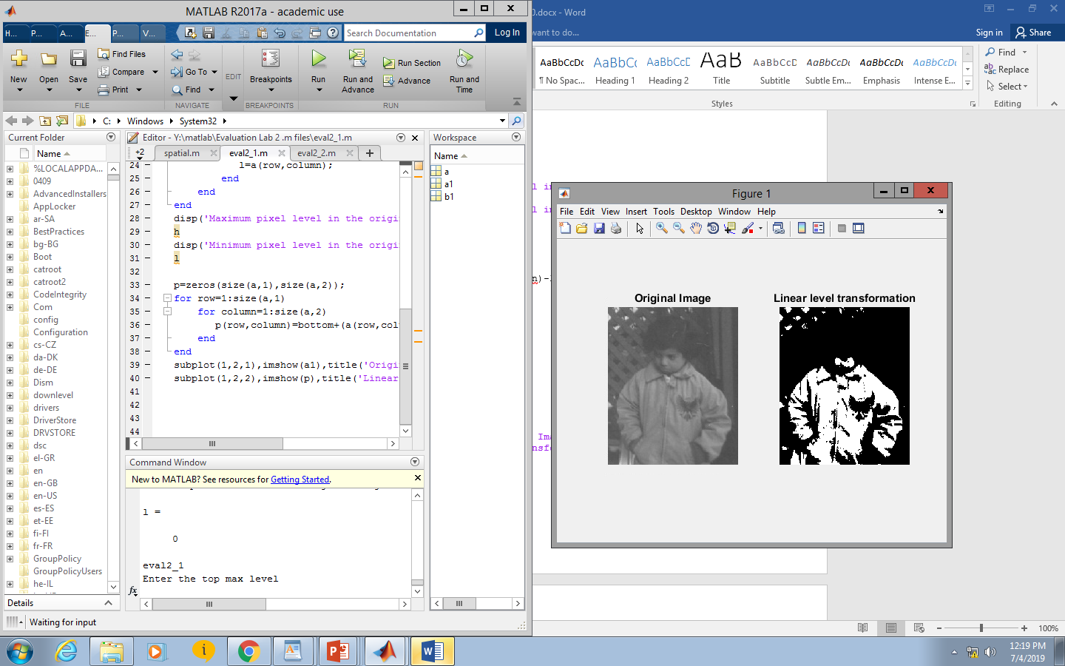

**2.Logarithmic Transformation :**

clear all;

a=imread('pout.tif');

a1=im2double(a);

b1=0.1*log(double(1+a1));

b1=mat2gray(b1);

subplot(1,2,1),imshow(a),title('Original Image');

subplot(1,2,2),imshow(b1),title('Log transformation');

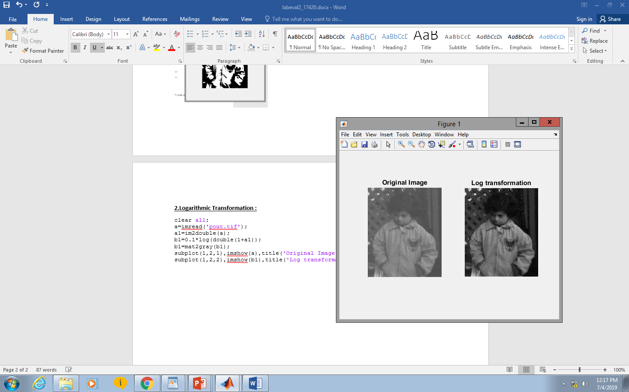

**Image Negative:**

c1=(255-a1);

c1=mat2gray(c1);

subplot(1,2,1),imshow(a),title('Original Image');

subplot(1,2,2),imshow(c1),title('Image Negative');

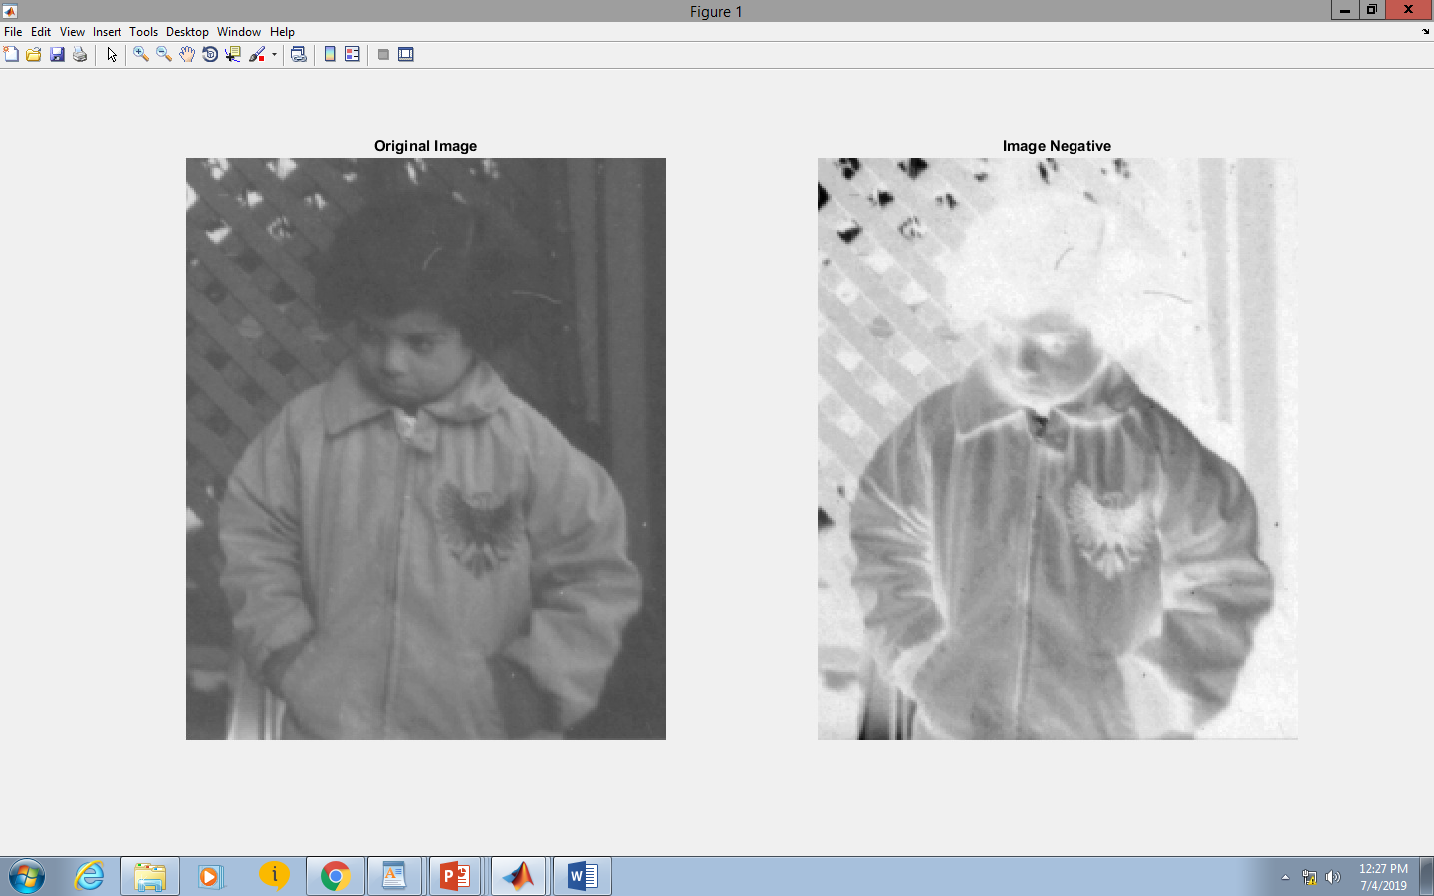

**Gamma transformation**

**FOR g<1 Dark->BRIGHT**

a2=imread('Fig0308(a)(fractured_spine).tif');

m2=im2double(a2);

c2=1;

g2=0.6; %g<1

for row=1:size(m2,1)

for column=1:size(m2,2)

if m2(row,column)>0

s2(row,column)=c2*(m2(row,column).^g2);

end

end

end

s2=mat2gray(s2);

subplot(1,2,1),imshow(m2),title('Original Image');

subplot(1,2,2),imshow(s2),title('Gamma transformation ');

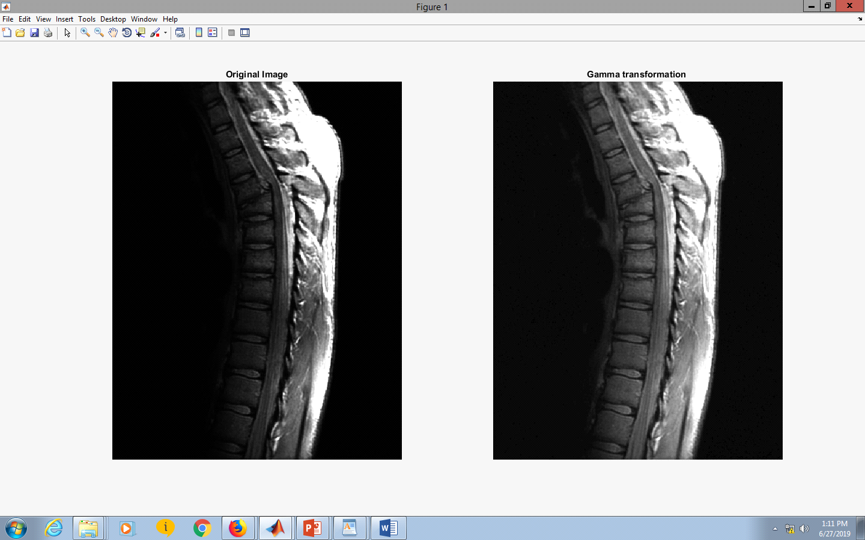

**FOR g>1 Bright->DARK**

a2=imread('Fig0309(a)(washed_out_aerial_image).tif');

m2=im2double(a2);

c2=1;

g2=4; %g>1

for row=1:size(m2,1)

for column=1:size(m2,2)

if m2(row,column)>0

s2(row,column)=c2*(m2(row,column).^g2);

end

end

end

s2=mat2gray(s2);

subplot(1,2,1),imshow(m2),title('Original Image');

subplot(1,2,2),imshow(s2),title('Gamma transformation ');

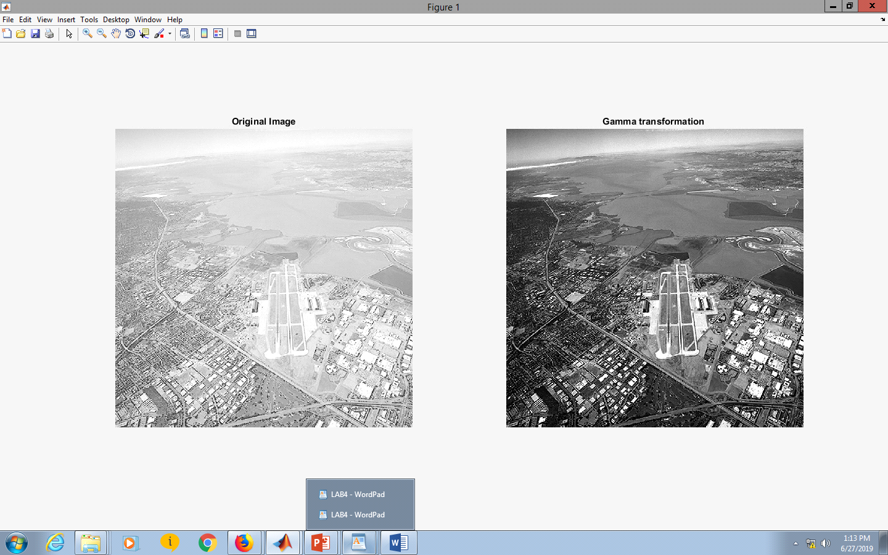

**Histogram Equalization**

clear all;

i=imread('pout.tif');

i2=histeq(i);

subplot(1,2,1),imshow(i),title('Original Image');

subplot(1,2,2),imshow(i2),title('Histogram Qualization');

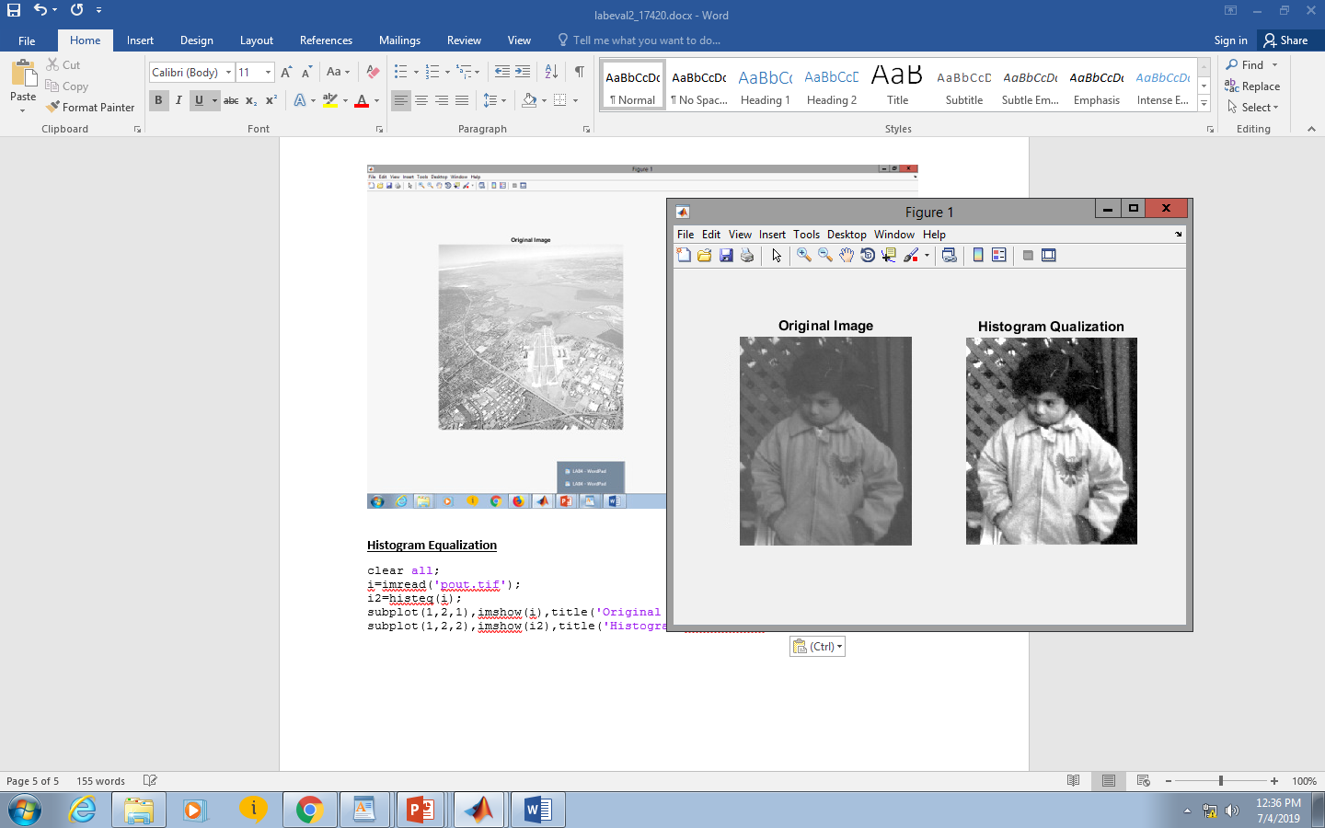

**HISTOGRAM**

subplot(1,2,1),imhist(a1),title('hist1');

subplot(1,2,2),imhist(i2);,title('hist2');

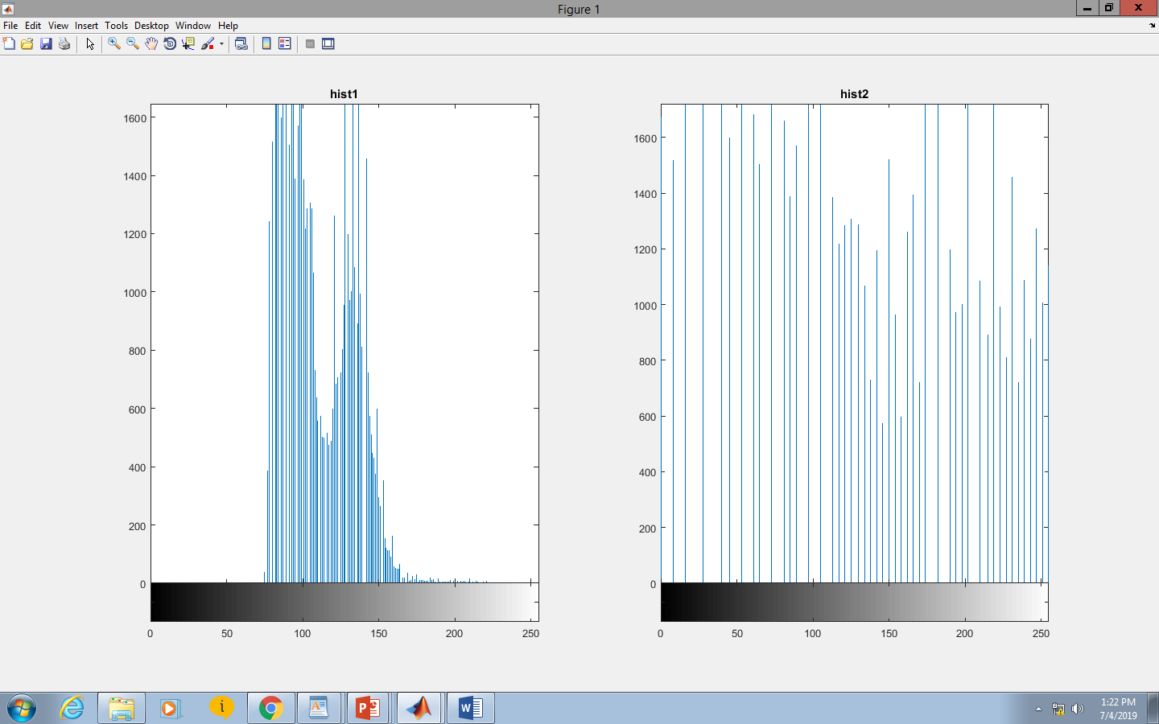

**Bit plane slicing**

p=imread('pout.tif');

p1=im2double(p);

r=size(p,1);

c=size(p,2);

a=zeros(r,c);

b=zeros(r,c);

a1=zeros(r,c);

b1=zeros(r,c);

d=zeros(r,c);

%a

for i=1:size(p,1)

for j=1:size(p,2)

a(i,j)=bitand(p1(i,j),128);

end

end

for i=1:size(p,1)

for j=1:size(p,2)

b(i,j)=bitand(p1(i,j),64);

end

end

imshow(p1),figure,imshow(a),figure,imshow(b);

%b

for i=1:size(p,1)

for j=1:size(p,2)

a1(i,j)=bitand(p1(i,j),128);

end

end

for i=1:size(p,1)

for j=1:size(p,2)

b1(i,j)=bitand(p1(i,j),64);

end

end

for i=1:size(p,1)

for j=1:size(p,2)

d(i,j)=bitand(p1(i,j),32);

end

end

imshow(p1),figure,imshow(a1),figure,imshow(b1),figure,imshow(d);